

**Software Engineering**

**Semester: 2021 Fall**

**Student Name:__________________**

**Student ID:_____________________**

**Document: Design Process**

**Version:**

# Design Document

1. **System Architecture**
2. **Class Design**

Student, Teacher, Admin

Role

Course

Arrangement

Class (Course)

1. **Database Design (6 tables)**

Person Table

Role Table

Person’s role Table

Course Table

….

CourseArrangement Table

Class Table

1. **Function Design**

4.1 Log in (All Roles)

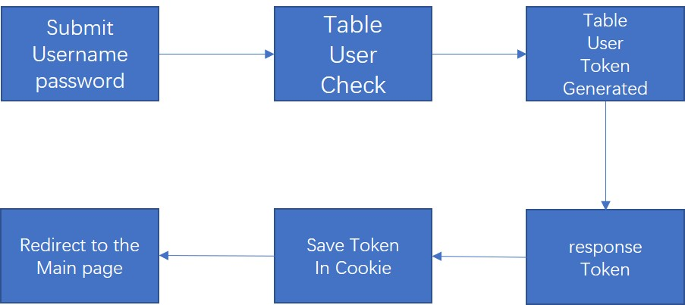

4.2 Log out (All Roles)

4.3 Authentication (All Roles)

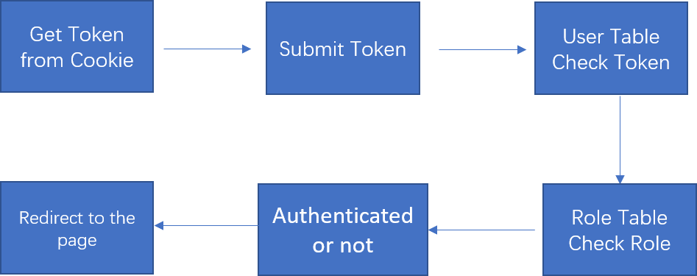

4.4 Create Course (Admin)

4.5 Create Teacher (Admin)

4.6 Arranging Course (Admin)

4.7 Select Courses (students)

4.8 Withdraw courses (Student)

4.9 Show a Course Information (All Roles)

4.10 Show the class of a Course (Teachers)

4.11 Show student’s TimeTable (students)

4.12 Show Teacher’s TimeTable (Teachers)

4.13 Scoring a student in a Class (Teachers)

4.14 Viewing student’s courses’ score (students)

1. **Prototype UI for each Function**

**Except 4.3**